Module 8: Portfolio Milestone-Option #1: Using Predictive Analytics to Solve Industrial Challenges
Kimberly Statham
MIS530 – Predictive Analytics
Colorado State University – Global Campus
Dr. Vincent Agboto
June 25, 2020

Controlling Type 2 Diabetes with Self-Management Behaviors
This portfolio project for MIS530 uses SAS® Enterprise Miner’s™ data mining and predictive analysis tools to model how these tools can be used to predict the personal characteristics of type 2 diabetes patients that are willing to self-manage their disease. The data source for this project is a CSV file that contains completely made up information that represents data from a self-administered survey responded to from type 2 diabetes patients. The remainder of this paper will read as if this is an actual predictive analysis study on self-management of type 2 diabetes, but the data used for this analysis is completely fictional.
Executive Summary
Type 2 diabetes develops when the human body does not respond well to insulin or the pancreas is unable to produce enough insulin to control the level of glucose in the bloodstream (Mayo Clinic, n.d.). There is no cure for type 2 diabetes but studies have shown that with lifestyle changes such as diet changes, weight loss, and exercise a person may be able to maintain normal glucose levels without medication.
The occurrence of type 2 diabetes is increasing dramatically. The projected growth of type 2 diabetes is expected to exceed the number of patients that primary care physicians can support. To help the large number of patients with this disease and to minimize the burden on the healthcare system, increased patient participation is needed, which includes self-management (Du Pon, E., Kleefstra, N., Cleveringa, F., van Dooren, A., Heerdink, E., and van Dulman, S., 2020).
Patients with diabetes need a high-level of responsibility to make lifestyle changes required for self-care behaviors (Wang, W., Lin, H., Hung, L., and Lo, Y., 2020). Studies have shown that patients who practice self-management to control their diabetes have a greater success than those patients who rely on medical treatments (Wang et al., 2020).
Why are some patients more reluctant to take control of their diabetes than others? What measures can be taken to reduce this reluctancy? These are the question we expect to answer with results from a predictive analysis study using non-health related information from survey responses of type 2 diabetes patients. The results of this study may provide insightful information for developing improved diabetes education programs and better mobile health apps that will encourage self-management of type 2 diabetes.
Predictive Analysis Process
The CRISP-DM methodology will be used in this project. The business understanding will be specified in business objectives, the data understanding will be defined in the data section, the data preparation and modeling will be conferred in the modeling section, and the evaluation will be defined under the evaluation heading. The deployment phase will not be covered in this project.
Business Objective
The business objective of this project is to identify non-health related characteristics that affect self-management behaviors in diabetes type 2 patients. The predicted variables that have the most influence on a patient’s willingness to take control of their disease will be assessed to determine if these factors are related to human characteristics that can be learned or changed.
The business objective success criteria are that useful insights into personal characteristics that influence self-care of diabetes type 2 patients are exposed by data mining techniques and prediction models. These insights will be validated by a minimum accuracy of 75% in predicting if a patient practices self-management of their diabetes.
Goals and Assessments
The factors to be explored are from a self-administered survey responded to by type 2 diabetes patients. The survey questions are grouped into three categories: demographics, health literacy, and self-efficacy. The goal will be to determine if any of the highest worth factors that influence a person’s desire to take control of their diabetes fall into the health literacy and self-efficacy categories. The criteria to be used to confirm the results of the goal is that the most accurate algorithm correctly identifies those patients who are self-managing their type 2 diabetes 75% of the time. The validation dataset will be used to assess the accuracy of the model. The validation data is 50% of the survey records, randomly selected.
SAS® Enterprise Miner™ will be used for the data exploration and predictive analysis. The data from the surveys will need to be manually entered into an Excel spreadsheet and then exported to a CSV file format so that it is readable by SAS. The data to be analyzed is small and there are no performance requirements so SAS Enterprise Miner will be run on only one computer system for this study.
Table 1
Modeling Risks with Associated Resolution
Risk | Resolution
Incorrect manual entry of survey results into Excel. | Risk minimized by having a second person proofread the Excel spreadsheet.
Minimal data analyst experience using SAS Enterprise Miner. | Accepted. SAS Institute has excellent reference resources on Enterprise Miner as well as technical support available 24x7.
Small amount of records available for the predictive modeling which could slant accuracy of the model. | Accepted. There is no additional data at this time. Based on evaluation of the model it will be determined if additional surveys will be administered to increase the dataset size.

Project Plan
The project plan, including durations and resources, is shown below in table 2. The only known risk to this project plan is obtaining time from the subject matter experts as they reside outside of our organization.
Table 2
Project Plan
Phase | Time | Resources | Notes
Business Understanding | 1 week | Sponsoring Manager, Project Manager, Business Analyst, Data Analysts
Data Understanding | 2 days | Project Manager, Business Analyst, Data Analysts, Subject Matter Experts (SME), | There are two SME’s. One is a psychologist who specializes in self-concept. The other is a SME on creating diabetes disease literature.
Data Preparation | 2 weeks | Business Analyst, Data Analysts | Data Preparation includes manual entry of survey results into Excel.
Modeling | 2 weeks | Data Analysts | There will be two data analysts paired for the entire modeling phase for learning and knowledge depth reasons.
Evaluation | 1 week | Project Manager, Business Analyst, Data Analysts

The Data
The initial variables to be explored are from responses to a self-administered survey from three metropolitan medical facilities, each located in a different region of the United States. The survey was developed by two business analysts in our organization with input from outside resources that specialize in the treatment of diabetes, development of education materials on self-caring for diabetes, and the psychology of self-efficacy. The survey consists of 20 multiple choice questions. The questions are grouped into three categories: demographics, diabetes type 2 health literacy, and self-efficacy. These groupings were made because the focus of this study is to determine if factors other than demographics contribute to a patient’s willingness to self-manage their diabetes. The survey responders are a sampling of type 2 diabetes patients belonging to one of two groups – those willing to self-manage their diabetes and those who are not. The data set contains 305 records with 21 variables.
Table 3
Dataset variable descriptions
Category | Variables | Description
diabetes type 2 health literacy | understanding_of_diabetes_2, where_did_you_get_your_knowledge, Do_you currently_use_an_app_to_m | 3 variables
self-efficacy | Do_you_have_life_goals, How_well_do_you_forgive_yourself, feelings_of_failure, how_many_days_per_week_do_you_ex, how_well_do_you_follow_simple_di, level_of_honesty, level_of_responsibility | 7 variables
demographic | Age, gender, health_insurance, highest_education_level, home_owned_or_rented, household_income_per_year, size_of_household, Race, Region | 9 variables
Target | Responder | A value of 1 indicates that the survey taker is willing to self-manage their diabetes. A value of 0 indicates they are not willing to self-manage their diabetes.
Record Identifier | Responder_

Modeling
Data Preparation
Very little data preparation was needed aside from the manual data entry of responses into an Excel worksheet. Since the questions were all multiple choice, there were no outliers. There also were no missing values. Through trial and error, it was discovered that several of the variables that were ordinal, were not ordered correctly. The values of these variables were text and by specifying them as ordinal, the default order was alphabetic which was not the intent. This mistake was discovered from the first execution of the decision tree in which the very first split was on variable understanding_of_diabetes_2 and split by value less than “very well” and greater than or equal to “very well”. The next split on the “very well” node path was on this same variable. “very well” should have been the highest ordinal value and thus there should be no possible way to have a value greater than “very well”. After looking at the Modify group of nodes in Enterprise Miner, there was no obvious way to transform the order of these ordinal variables. The solution was to update the Excel worksheet and use sequential integers for the ordinal values instead of text with a one being the less desirable trait and the number of choices being the most desirable trait. For example, the values of "no understanding", "a little understanding", "some understanding", "pretty good understanding", "a lot of understanding" for variable understanding_of_diabetes_2 was transformed in the Excel spreadsheet to 1, 2, 3, 4, 5 respectively.
The Model Process
The first technique in the model is the StatExplore node. The results indicate that the variable with the most worth is the level of understanding of type 2 diabetes. This variable belongs to the diabetes type 2 health literacy category. The second variable with the highest worth is the level of how well simple directions are followed, which falls into the self-efficacy category.
The Data Partition node was used to allocate 50% of the data to training and 50% to validation. These allocations were based on the small number of records being used.
Two data modification nodes, Transform Variables and Principal Components were performed. The results from the Transform Variables only reduced the number of age groups from nine to seven. Principal Components did not reduce or transform any of the variables. Since these techniques changed the data very little or not at all, they were removed from the process flow but left in the diagram for historic purposes.
Neural Networks, Decision Trees, and Partial Least Squares were the first predictive modeling algorithms that were analyzed. The Decision Tree had the least accuracy (the most misclassifications) however it was beneficial to execute because this uncovered the issue with the ordinal variables not being in the proper order. Another benefit of the Decision Tree was that it reinforced the two highest worth variables from the StatExplore node as the initial split was made on the highest worth variable and the second split was made on the second highest worth variable.
Before the Neural Network was executed, Variable Selection was run. Neural Networks are resource intensive and can take a while to complete. Reducing the number of input variables can help performance. Variable Selection rejected three of the variables which were Region, Do you currently use an app to monitor your diabetes, and Do you have life goals.
The three predictive algorithms were connected to the ensemble node. The Ensemble node results indicated it was less accurate than the Neural Network algorithm. A Gradient Boosting node was then executed and it had better accuracy than the Decision Tree. The Decision Tree was then removed from the flow but left in the diagram for reference purposes. The Gradient Boosting node was then fed into the Ensemble node along with the Neural Network and Partial Least Squares. This time the results from the Ensemble node indicated it was less accurate than both the Neural Network and Gradient Boosting node so the Ensemble node was removed from the workflow and replaced with the Model Comparison node.
Figure 1.0
SAS Enterprise Miner Diagram Workflow for Diabetes Type 2 Self-management modeling
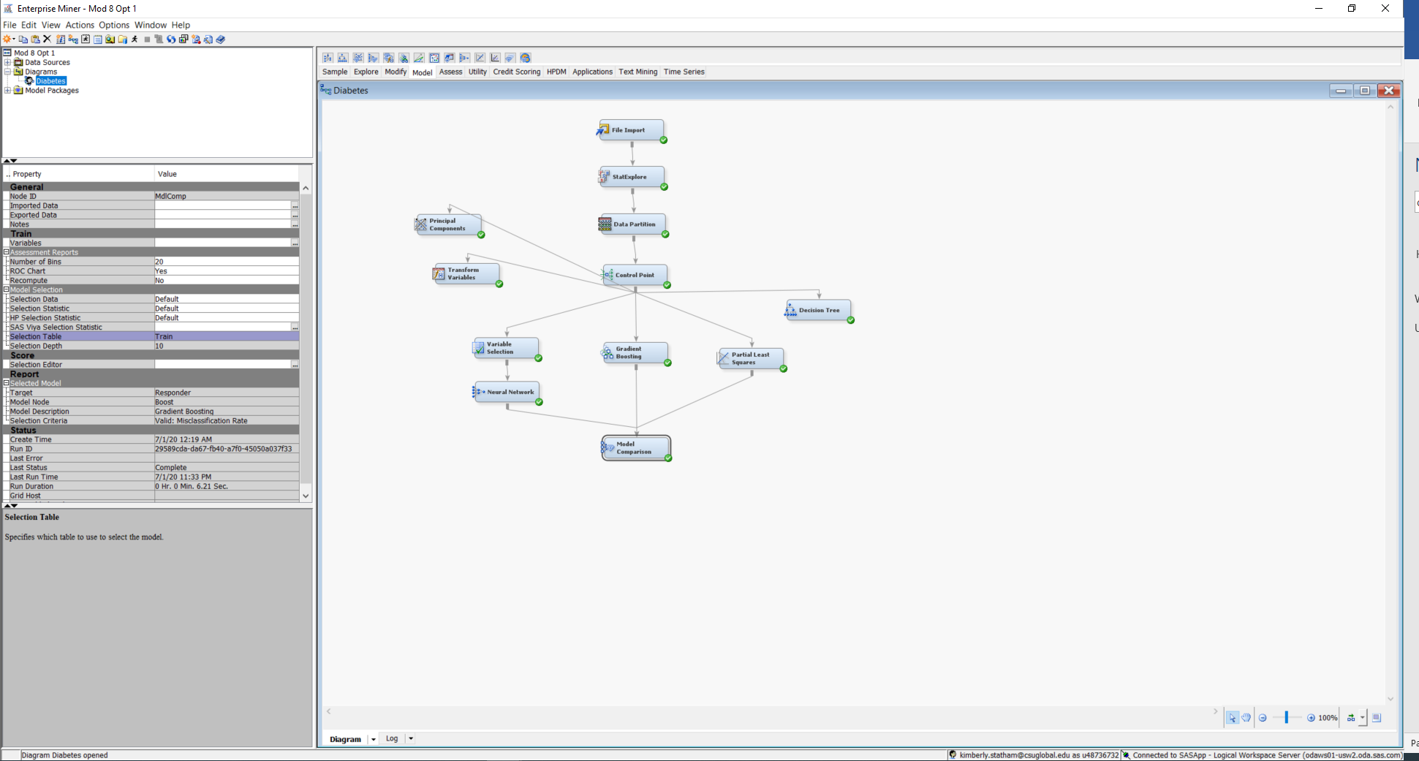
Figure 1.1
StatExplore Variable Worth chart
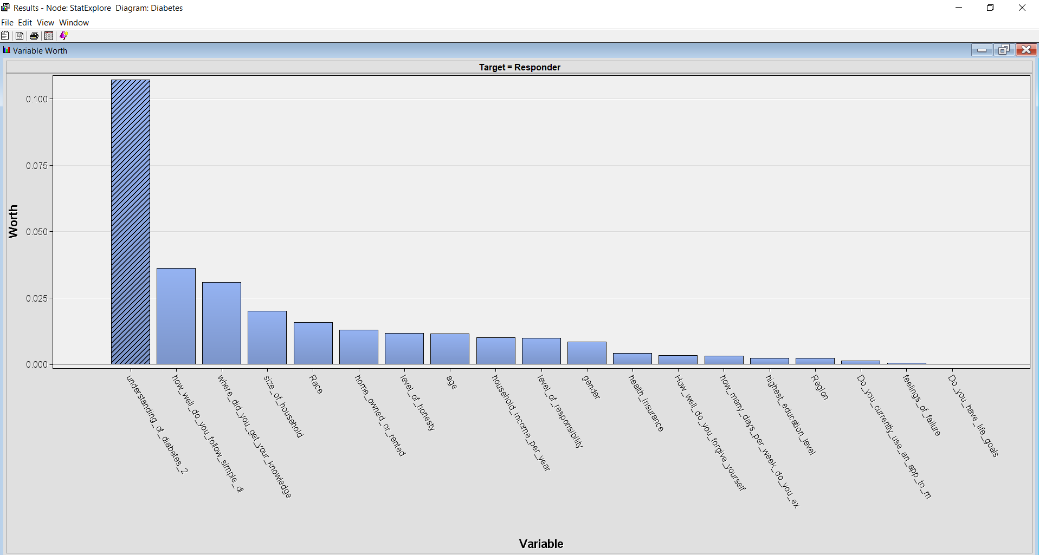
Evaluation
The Model Comparison shows that the Gradient Boosting algorithm had the best accuracy based on the lowest misclassification rate in the validation dataset. The misclassification rate for this algorithm was 20.9% and thus the correct classification rate was 79.1% which exceeds the business objective success criteria which was 75% accuracy. The Neural Network algorithm also met the success criteria as it’s accuracy on the validation dataset was 75.2%. The Gradient Boosting results also indicate that variable understanding_of_diabetes_2 had the highest importance and variable how_well_do_you_follow_simple_di had the second highest importance. The variable importance ranking along with the prediction accuracy of the validation dataset confirm that the variables related to the level of understanding of the type 2 diabetes disease and the ability to follow simple directions are important factors in determining if a patient will be willing to self-manage their diabetes.
Figure 2.0
Gradient Boosting Cumulative % Captured Results
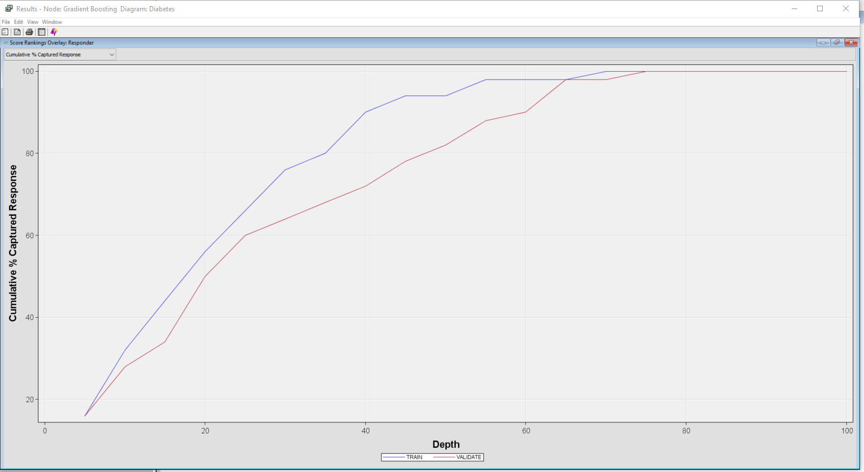
Figure 2.1
Gradient Boosting Variable Importance
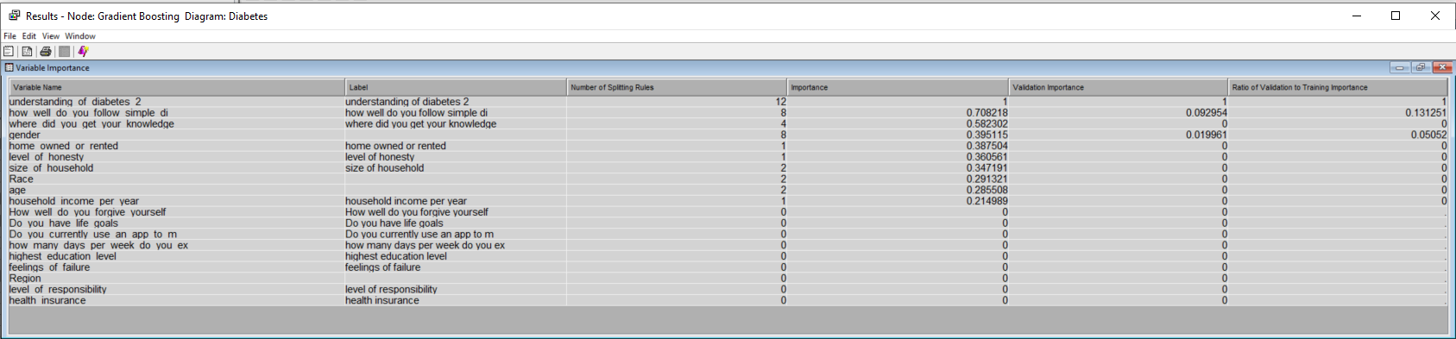
Figure 2.2
Gradient Boosting Classification Table Output
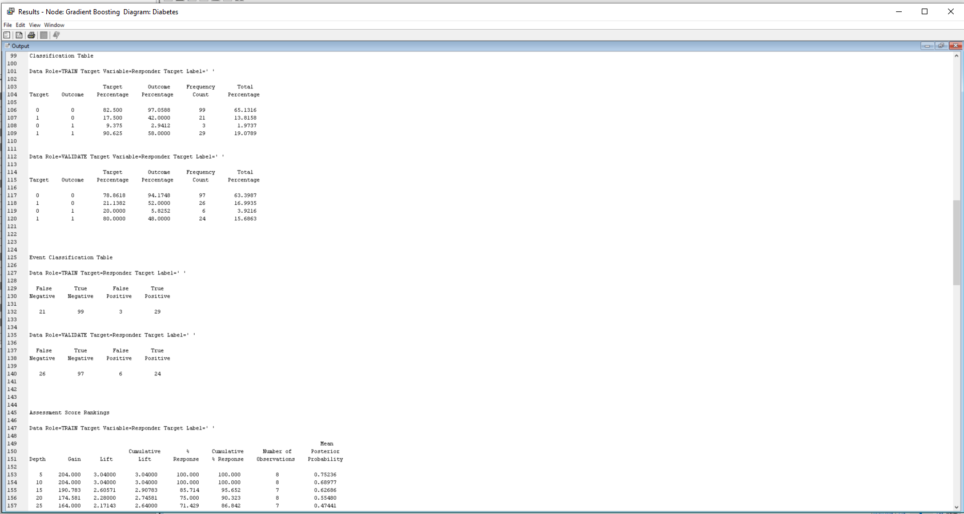
Figure 3.0
Model Comparison Fit Statistics
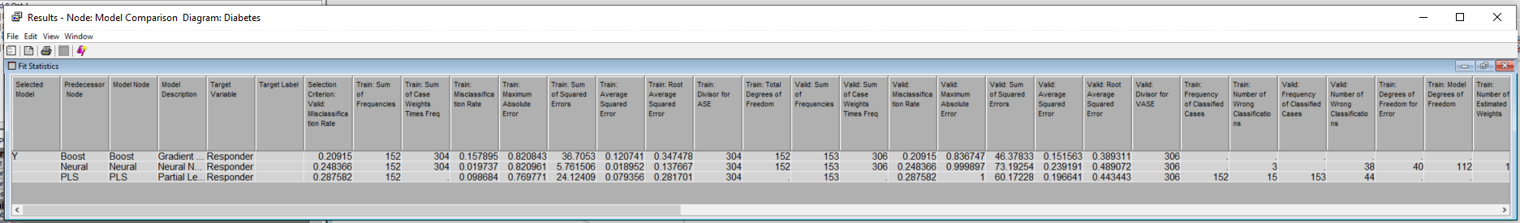
Figure 3.1
Model Comparison ROC Chart
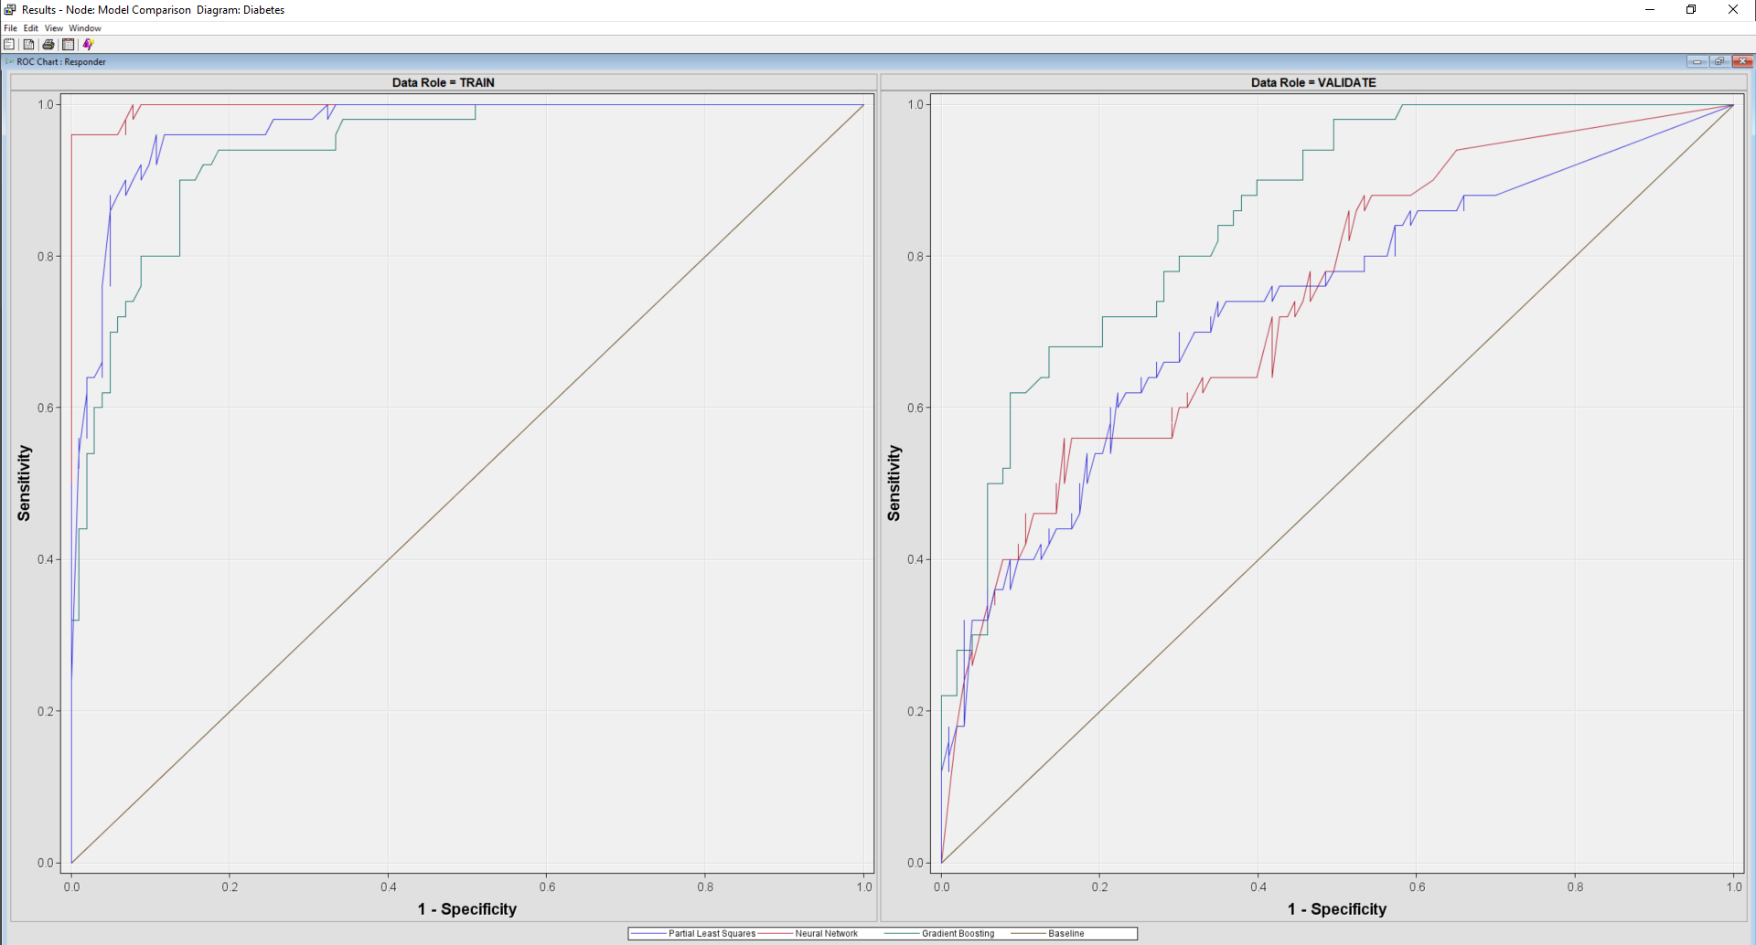
Figure 3.2
Model Comparison Misclassification Output
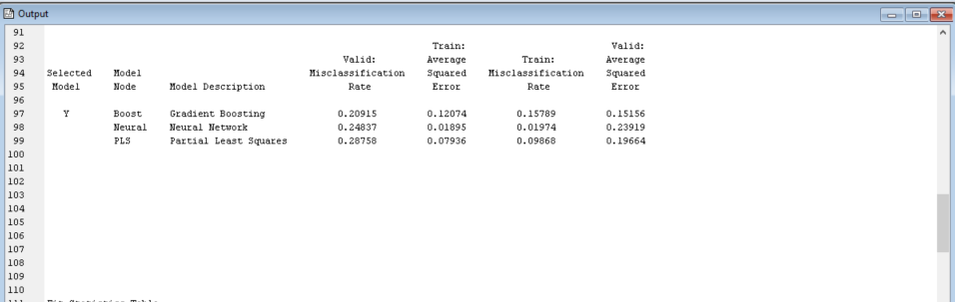

Summary
The findings of the predictive modeling show that characteristics related to how knowledgeable a patient is on type 2 diabetes and how confident a patient is on following simple instructions play an important role on how likely a patient is to self-manage their diabetes. This information is valuable to the health industry as improvements and availability of type 2 diabetes educational programs and mobile applications could increase the number of patients who self-manage their disease. It is important that the results of this study are communicated to those health organizations associated with providing care to type 2 diabetes as well as health insurance companies.
The next course of action will be to develop a deployment plan. This deployment plan, at a minimum, will include indentifying those organizations that should be interested in the results; developing a formal presentation geared towards health organizations; and creating a presentation roll-out schedule. An additional action that need to be taken in the near future is deciding if the prediction model needs to expand by exploring additional prediction algortihms, changing the parameter configuration of the existing algorithms, or obtaining additional data to run through the model.
References
Abbot, D. (2014). Applied predictive analytics: principles and techniques for the professional data analyst. JohnWiley & Sons, Inc. Ch. 13.
Babar, Z., Kousar, R., Hasan, S., Scahill, S., and Curley, E. (2019). Glycemic control through pharmaceutical care: a meta-analysis of randomized controlled trials. Journal of Pharmaceutical Health Service Research. Mar2019, Vol. 10 Issue 1. DOI 10.1111/jpha.1228. Retrieved from https://onlinelibrary.wiley.com/doi/abs/10.1111/jphs.12281
Chapman, P., Kerber R., Clinton, J., Khabaza, T., Reinartz, T., and Wirth, R. (2019). The CRISP-DM Process Model. CRISP-DM consortium. Retrieved from http://keithmccormick.com/wp-content/uploads/CRISP-DM%20No%20Brand.pdf
Du Pon, E., Kleefstra, N., Cleveringa, F., van Dooren, A., Heerdink, E., and van Dulman, S. (2020). Effects of the Proactive Interdisciplinary Self-Management (PRISMA) Program on Online Care Platform Usage in Patients with Type 2 Diabetes in Primary Care: A Randomized Controlled Trial. Journal of Diabetes Research. Hindawi. Volume 2020, Article ID 5013142. Retrieved from https://www.hindawi.com/journals/jdr/2020/5013142/
Frank, M. (2020). The Pillars of the Self-Concept: Self-Esteem and Self Efficacy. Excel at Life. Retrieved from https://www.excelatlife.com/articles/selfesteem.htm#:~:text=%20%20%201%20Self-confidence.%0AOne%20of%20the%20most,take%20risks%20because%20they%20understand%20that...%20More%20
Georges, J., Andersson, C., Thompson, J, and Wells, C. (2017). Advanced Predictive Modeling Using SAS® Enterprise Miner™ Course Notes. SAS Institute Inc. Retrieved from: https://csuglobal.instructure.com/courses/22915/modules/items/1100574
Giusti, A., Maggini, M., Colaceci, S. (2020). The burden of chronic diseases across Europe: what policies and programs to address diabetes? A SWOT analysis. Health Research Policy and Systems. Vol. 18 Issue 1. Retrieved from https://health-policy-systems.biomedcentral.com/articles/10.1186/s12961-019-0523-1
Huda, N., Nursalam, Sukartini, T., Muflikhah (n.d.). Analysis of the health tasks of families with diabetes mellitus. Indian Journal of Public Health Research & Development. Vol. 10 Issue 8. DOI 10.5958/0976-5506.2019.02276.9 Retrieved from: http://www.indianjournals.com/ijor.aspx?target=ijor:ijphrd&volume=10&issue=8&article=521
Ketema, D., Leshargie, C., Kibret, G. Assemia, M., Alamneh, A., Kassa, G., and Alebel, A. (2020). Level of self-care practice among diabetic patients in Ethiopia: a systematic review and meta-analysis. BMC Public Health. Vol. 20 Issue 1. Retrieved from https://bmcpublichealth.biomedcentral.com/articles/10.1186/s12889-020-8425-2
Mayo Clinic. (n.d.) Type 2 diabetes. Mayo Foundation for Medical Education and Research (MFMER). Retrieved from https://www.mayoclinic.org/diseases-conditions/type-2-diabetes/symptoms-causes/syc-20351193
Sarma, K. (2017). Predictive modeling with SAS® Enterprise Miner™: Practical solutions for business applications (third edition). SAS Institute Inc.
SAS Institute. (2018). Getting Started with SAS® Enterprise Miner 15.1™. SAS Institute Inc. Retrieved from: https://documentation.sas.com/api/docsets/emgsj/15.1/content/emgsj.pdf?locale=en
SAS Institute. (2020). SAS® Enterprise Miner™ 15.1: Reference Help. SAS Institute Inc. Retrieved from: https://documentation.sas.com/?docsetId=emref&docsetTarget=n1rk56ji9xtxxnn1q40urbumsno3.htm&docsetVersion=15.1&locale=en

Schmitt, A., Gahr, A. Hermanns, N., Bernhard, K., Huber, J., and Haak, T. (2013). The Diabetes Self-Management Questionnaire (DSMQ): development and evaluation of an instrument to assess diabetes self-care activities associated with glycaemic control. Health and Quality of Life Outcomes. Springer Nature. Retrieved from https://hqlo.biomedcentral.com/articles/10.1186/1477-7525-11-138
Wang, W., Lin, H., Hung, L., and Lo, Y. (2020). Non-health outcomes affecting self-care behaviors and medical decision-making preference in patients with type 2 diabetes: a cross-sectional study. BMC Medical Informatics and Decision Making. Retrieved from: https://www.ncbi.nlm.nih.gov/pmc/articles/PMC7181515/
Weinger, K., Butler, H., Welch, G., and La Greca, A. (2005). Measuring Diabetes Self-Care: A psychometric analysis of the self-care inventory-revised with adults. Diabetes Care. American Diabetes Association. Retrieved from https://care.diabetesjournals.org/content/28/6/1346

